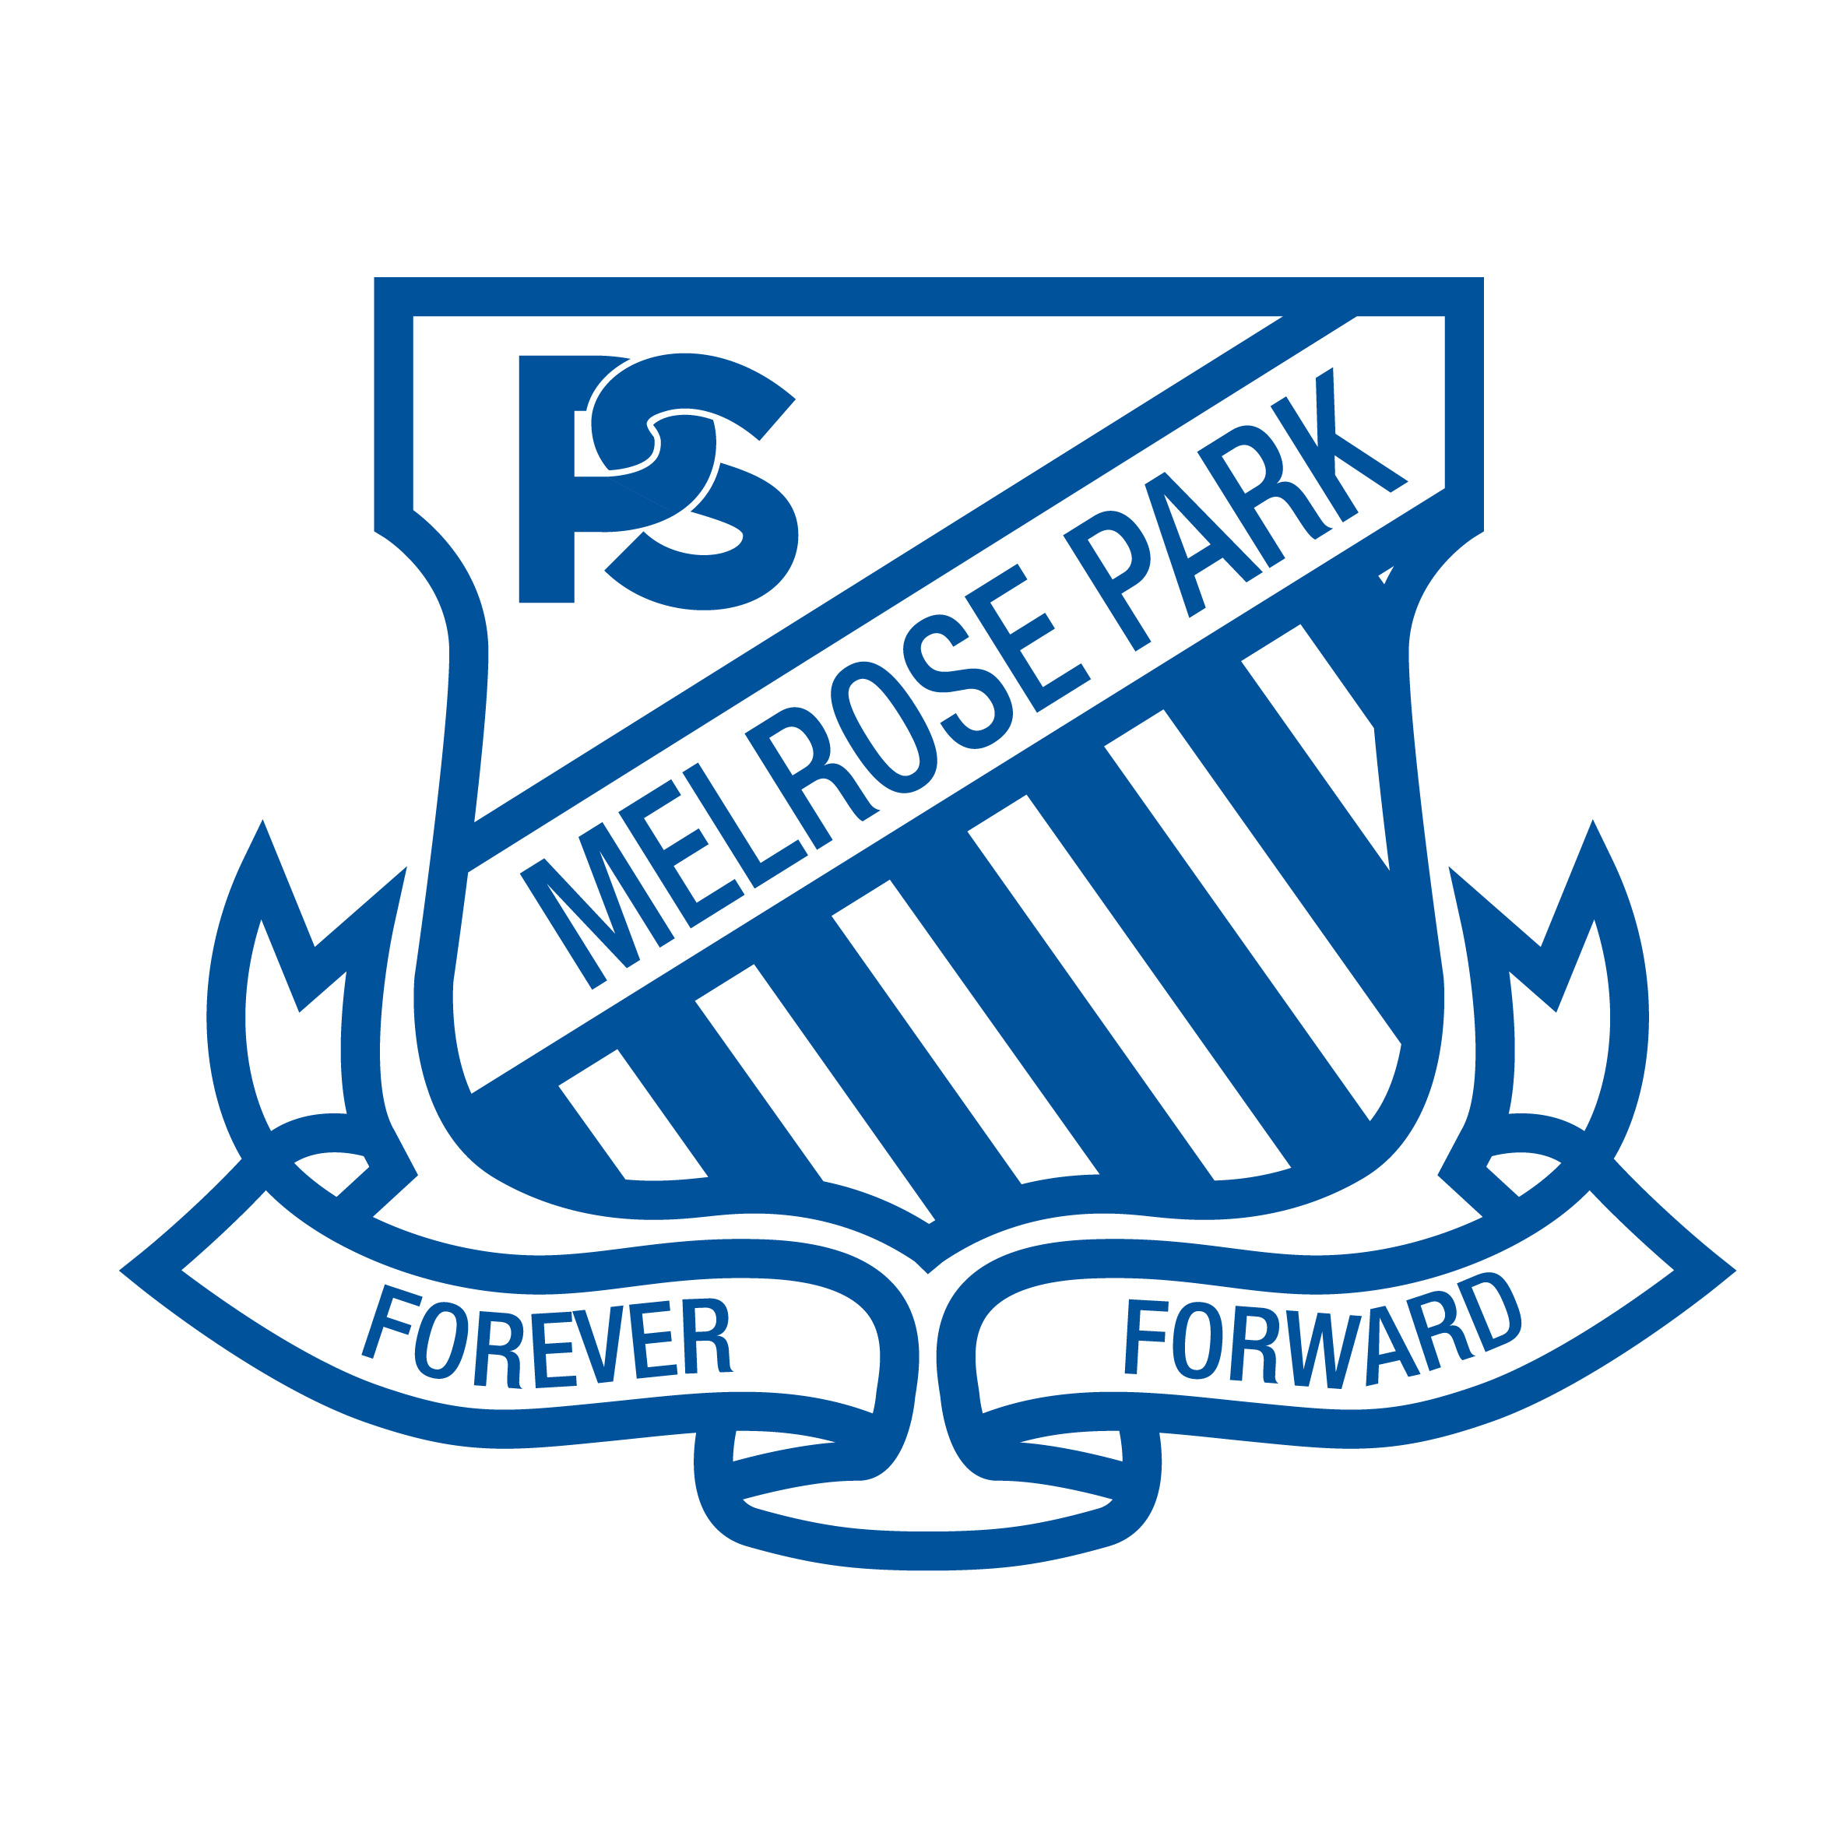
Permission to Publish - Specific Activity
Explanation of the activity
Musica Viva are visiting our school on Thursday May 30th 2019 and have requested the opportunity to take publicity photos and recordings during the incursion 'Adventures in Antarctica'. All students will watch the performance. Students with publicity permission will be seated together so that photos can be taken of them responding to the performance.
Description of the information and explanation of how the information will be collected
Musica Viva have requested taking photos and vision/sound recordings of the students interacting with the performers during the concert. They may also stage some photos with performers and students and interview students after the performance.
Explanation of where the information will be published
Promotional material obtained about your child may be published in print and online, e.g. on Facebook, on their website, in their brochure and other printed collateral.
Musica Viva will not use your child’s photograph/vision/sound recordings or work for anything other than educational purposes or the general promotion of Musica Viva.
If you sign this release form, it means that you agree to the following:
1. Musica Viva is able to use your child’s photograph/vision/sound recordings or work as many times and in as many ways as it requires including online/on-demand footage;
2. Your child’s photograph/vision/sound recordings or work may be reproduced in colour or black and white and may be altered, distorted or blurred for design purposes;
3. You will not be consulted about the specific context in which your child’s photograph/ vision/sound recordings or work appears.

Permission to Publish
I give permission for my child to be interviewed, photographed and filmed on Thursday May 30th, 2019 by the media unit of Musica Viva for promotional purposes. I give permission for this material to be published in print and electronic media.
Child’s name (please print): ……………………………………………………. Class:
Parent/ Guardian’s Signature: .…………………………………………………
Parent/Guardian’s name (please print): ………………………………………. Date: ……………….
Please return to the school office by Wednesday 29th May 2019.

